**Chapter 2:**

2.1 **About Arduino:**

Adruino is a well-known microcontroller build on the ATmega328P. It contain some input and output pins by which it takes input to analysis the inputted data and give the analyzed data as output to its user. Among them 14 input and output pins 6 can be used as PWM output and 6 are used for analog input. There is a 16MHz quartz crystal, a USB connection, an ICSP header and a reset button. Every important parts are present here in order to support the function of microcontroller. In order to operate it the required power can be supplied by connecting it to a computer using USB cable or using an adapter or a battery.

Its durability is good and it can be repaired easily if anything goes wrong with the microcontroller. One just have to replace the chip which will cost a little to fixed the microcontroller. The uno word was chosen to mark the release of IDE of Arduino. It is a software which is used to give command to the Arduino how it is going to analyze the inputted data. Using this software the code for Arduino microcontroller is written, compiled and also can be tested. Then using this IDE this code is being burned to the microcontroller to perform a certain operation. Uno is the first microcontroller that uses USB among the Arduino board. Different types of sensors and modules can be connected to it and they can work together on a certain problem.

**2.1.1 Arduino uno:**

Arduino uno is a version of Arduino microcontroller family build on ATmega328P. Unlike all other microcontroller it also contains some input and output ports. By which it take data from sensor and give analyze data to the user. Unlike other arduino microcontroller it also contain 16MHz quartz crystal, a USB, an ICSP header and a reset button. Basically its power supply is given from the computer with which it is connected through USB data cable. This USB data cable is also used to burn the code based on which it will execute the analysis operation.

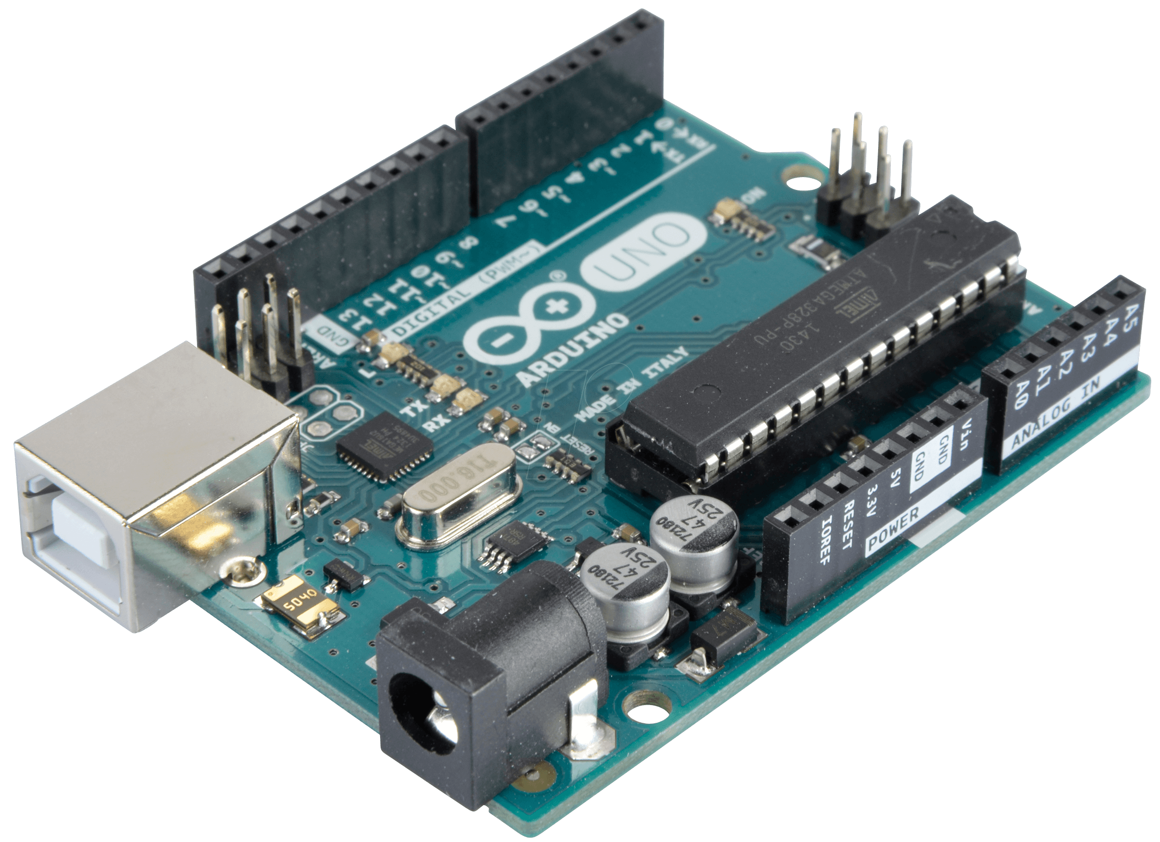

Fig 2.1: Arduino Uno

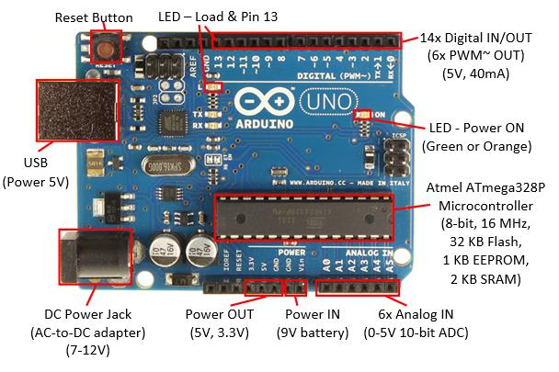

Fig 2.2: Different parts of Arduino Uno

**2.1.2 Specification of Arduino Uno:**

|  |  |
| --- | --- |
| Microcontroller | ATmega328P |
| Execution Voltage | 5V |
| Inputed Voltage (recommended) | 7-12V |
| Input Voltage (limit) | 6-20V |
| Digital I/O Pins | 14 (6 pins are used as PWM output) |
| PWM Digital I/O Pins | 6 |
| Analog Input Pins | 6 |
| DC Current per I/O Pin | 20 mA |
| DC Current for 3.3V Pin | 50 mA |
| Flash Memory | 32 KB of which bootloader use 0.5 KB |

**2.1.3 Power Supply**

As an electric device arduino uno needs power supply in order to operate its work and analyze the data. Power can be supplied to arduino uno using AC to DC adapter or battery. The most popular way of supplying power to arduino uno is using USB cable by which it is connected to the computer. The external power can be provided by the connector with a 2.1 mm center positive attachment to the board’s energy jak. On GND and power connector’s VIN stack header leads from the battery can be embedded. Between 6V to 20V this board can work. If it is connected under 7V, the 5V stick may have under 5V and the board might be unstable. If more than 12V is supplied then the voltage controller may be overheated that can damage the board. So the ideal range is from 7V to 12V.

**2.1.4 Power Pins**

**VIN:** This pic is used when arduino is using an outer power source. Voltage can be supplied through this pin. When voltage is provided by means of power jack then access it by this stick.

**5V:** This control the power supply of microcontroller and different segment of the board. This can be supplied from VIN by means of an on board regulator or provided by USB or other controlled 5V power supply.

**3.3V:** The on board FTDI chip produces a 3.3V supply and the max amount of current draw is 50 mA.

**GND:** Ground pin.

**2.1.5 Memory:**

In order to store the code the ATmega 328 has 32 KB of flash memory of which 0.5 KB is used by the boot loader. Not only that, it contains a 2KB of SRAM and 1KB of EEPROM. Using EEPROM library this 1KB of EEPROM is read and written.

**2.1.6 Input and Output Pins:**

It will be easy to understand, if we describe the arduino pins using a pin diagram. So the pin diagram of an arduino is given below.

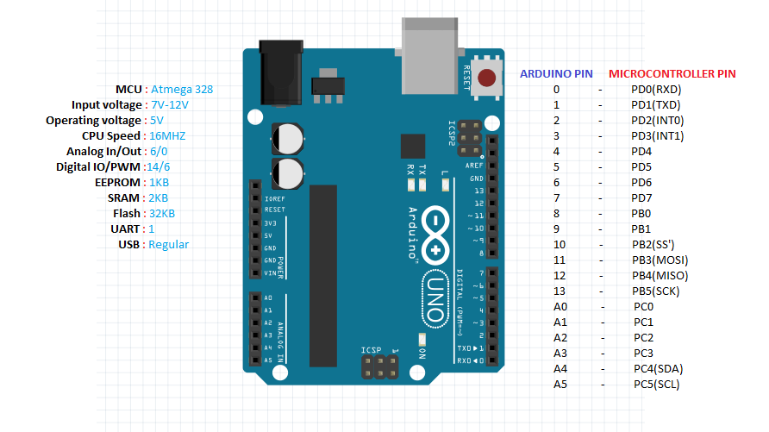

Fig 2.3: Input and Output Pin of Arduino.

* Analogue Reference pin.
* Digital Ground pin.
* 0 and 1 are RXD and TXD pins. When we are about to use arduino for serial communication this pins can’t be used as digital input pin.
* Digital input (pin 2 to 13).
* Analogue input (pin A0 to A5).
* There is a Power pin 5V (marked as 5V).
* Two ground pin (marked as GND left middle).
* Reset button (Top right red one0).
* External power supply (7V to 12V) (Top left).
* USB port.

As we mention earlier arduino has 32 pin among them 6 are analogue and 14 digital pins. In order to use those digital pins as input and output we need the help of some functions like pin mode(), digital read() and digital write(). There is a maximum capacity of those pins and it is 40mA. Each of those pins have internal pull-up resistors of 20-50K ohms. Some of the pin can work on some special function.

**PWM:** 3,5,6 and 9-11 pins use analogue write() function to provide 8bit PWM output.

**SPI:** 10 (SS), 11 (MOSI), 12 (MISO), 13 (SCK). These pins bolster SPI correspondence, which although gave by the basic equipment, isn't right now incorporated into the Arduino dialect. The SPI pins are additionally broken out on the ICSP header.

**External interrupt:** 2 (interrupt 0), 3 (interrupt 1). This two pins are used to design trigger a hinder on a low esteem, a rising or falling esteem edge, or an adjustment in esteem.

**A4 (SDA) & A5 (SCL):** Support TWI communication utilizing the wire library (documentation on the wiring site).

**LED13 :** There is a worked in Driven associated with computerized stick 13. at the point when the stick is HIGH esteem, the Drove is on, when the stick is LOW, it's off.

**Serial :** 0 (RX) and 1 (TX). Used to get (Rx) and transmit (TX) TTL serial information. Pins 0 and 1 are additionally associated with the comparing pins of the FTDI USB-to-TTL Serial chip.

6 analogue input of arduino give 10bit of resolution. Its measurement range is ground to 5V by default. Though the upper range can be changed by AREF pin and analogue reference() function.

**AREF:** It provides the reference voltage while working on analogue input using analogue reference().

**Reset:** It take (RX) and transmit (TX) TTL serial information. Pins 0 and 1 are additionally associated with the comparing pins of the FTDI USB-to-TTL Serial chip.

**2.1.7 LEDs**

Arduino has four LEDs. They are L, RX, and TX and ON.

**RX and TX LEDs:** They indicate that the data is sent to the arduino or not through the USB. The TX LED turned into yellow when the data sent from the arduino to PC USB port. The RX LED turned into yellow when the data is sent from USB port to arduino.

**ON LED:** This LED will illuminate green color when the arduino is turned on. That means the power is supplied to the arduino. This will indicate you that your arduino is acting well. If the this light is gleaming or turned off that means there is a problem on the supply of power.

**L LED:** This is the only LED which can be controlled. Other LEDs are lighted up based on the current condition of the arduino. This Led is associated with the Arduino principle chip and one can turn it on or off when you begin composing code and transferring on it.

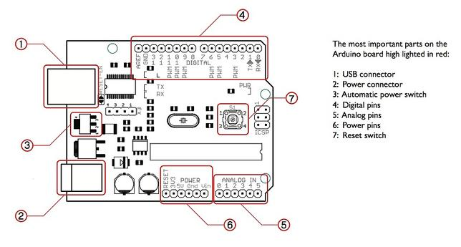

Fig 2.4: Arduino Schematic Diagram.

**2.2 Biomedical Sensor Pad:**

In order to measure the EEG, ECG and EMG levels one can use biomedical sensor pad which is a disposable electrode. There are so many heart related diseases when heart should be monitored most of the time. In this purpose these little pads can be very helpful for short-term monitoring of Neurofeedback and Biofeedback purposes. They are so popular among the users because of their integrated latex free gel. This gel will help the pad to adhere to our skin so that there will be no problem of taking the data from the heart. The snap of the connector is built in such a way that there is no difficulty to connect or remove it with the sensor cable’s electrode.

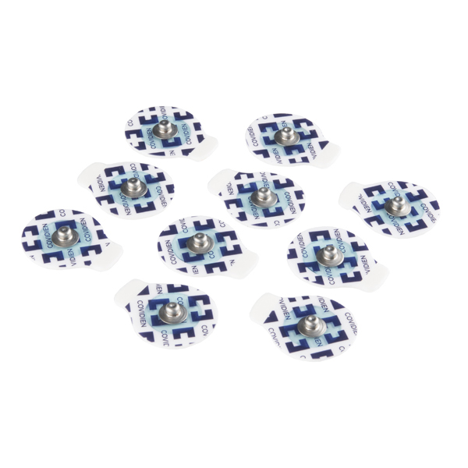

Fig 2.5: Biomedical Sensor Pad.

**2.2.1 Features of Biomedical Sensor pad**

* Light weight small size pad.
* Connector that connect the pad to the electrode.
* Latex free gel helps to adhere to the skin.
* Short-term useable.
* Helps to measure ECG, EEG and EMG levels.
* Dimensions: 24mm x 1mm.

**2.3 Sensor Cable - Electrode Pads**

# Among the three components which help to collect the ECG, EEG and EMG levels this one is the simplest one. It is simple in structure but its contribution in collecting data is not that much simple. With the help of the Biomedical sensor pad it collect the data and send it to the Single Lead Heart Rate Monitor - AD8232 for further process. It’s a 24” long cable with a feature of 3.5mm audio jack connector on one end and other end contain three snap style receptacles for Biomedical sensor pad. Each cable has a red, blue and a black electrode pad lead.

**2.3.1 Features Of Sensor Cable - Electrode Pads**

* It passes the data from Biomedical sensor pad to AD8232.
* It has audio jack connector and snap style connector, which makes the connection with the biomedical sensor pad and heart rate monitor easier.
* 24” long.
* 3.5 mm audio jack.
* 3 electrode lead for better measurement.

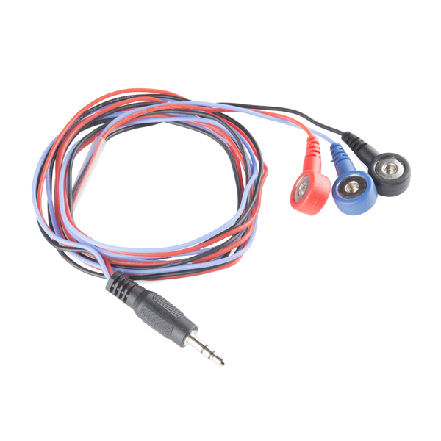

Fig 2.6: Sensor Cable - Electrode Pads

# 2.4 Single Lead Heart Rate Monitor - AD8232

# Single lead heart rate monitor AD8232 is a smart board which is cost effective and it’s used to measure the electrical activity measurement of the heart. This electrical activity can be charted as an ECG or Electrocardiogram and output as an analog reading. When we try to take the electrical activity of heart that data can be extremely noisy. So if we try to draw an ECG from that data we won’t be able to draw it perfectly. In order to draw a clear ECG signal from the PR and QT interval easily, this single lead heart rate monitor AD8232 works as an op amp. For ECG and other bio potential measurement applications, this AD8232 works as an integrated signal conditioning block. It is being designed in such a way that it can amplify, extract and filter small bio potential signal when there is a lots of possibility of noisy signal. For example noisy signals created for motion or remote electrode placement.

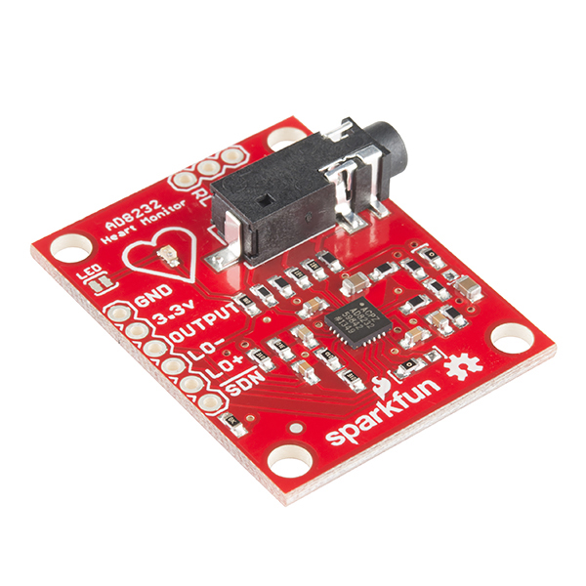

Fig 2.7: Single Lead Heart Rate Monitor - AD8232

**2.4.1 Pin connections:**

AD8232 heart rate monitor has nine pin connections from the board that you can solder pins, wires, or other connection. Pins are described from the following figure.

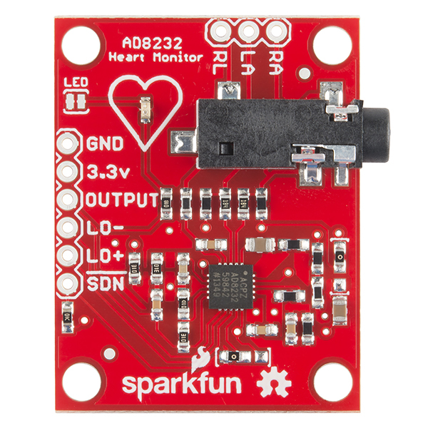

Fig 2.8: Pins of AD8232

* GND
* 3.3V
* Output
* LO-
* LO+
* SDN
* RA, LA and RL pins.

SDN, LO+, LO-, OUTPUT, 3.3V, GND provide essential pins provide essential pins that are required to operate the monitor with Arduino or any other development boards.

This board also contains three more pins like RA (Right Arm), LA (Left Arm) and RL (Right Leg). These pins are used for user custom sensor.

There is a LED attached to the monitor board which will pulse with the rhythm of the heart beat.

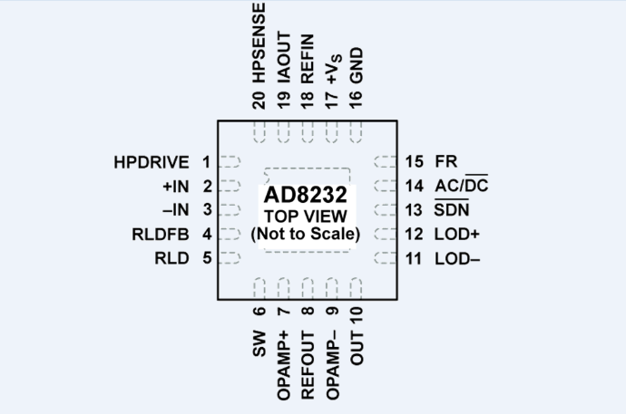

Fig 2.9: Schematic Diagram of AD8232

**2.4.2 Features of AD8232:**

* Measures the electric activity of heart.
* Used for amplifying noisy signal.
* It has 9 pin connections in order to work with Arduino or Other development board.
* RA, LA, RL pins are used for user custom sensors.
* It has an LED to indicate the Heart Beat.
* It has a 3.5mm audio port to connect with electrode pad.
* It works with Electrode pad and Biomedical sensor pad.

**2.5 HC-05 Bluetooth Module:**

The most popular Bluetooth SPP (serial port protocol) module is HC-05 module designed for wireless serial data communication system. This module can be used in two configurations those are known as master and slave configurations which made this data communication system a great medium. This serial port Bluetooth module is fully qualified Bluetooth V2.0+EDR (Enhanced Data Rate) 3Mbps Modulation with complete 2.4GHz radio transceiver and baseband. It uses CSR Bluecore 04‐External single chip Rluetooth system with CMOS technology and with AFH (Adaptive Frequency Hopping Feature).

**2.5.1 About Bluetooth Module HC-05**

As we know that this module can work in two configurations but by default it is configured as slave. This configuration can be changed only by AT COMMANDS. The difference between the two configurations is, when it is configured to slave mode it cannot initiate a connection with other device. It can only accept connections when it is in slave mode. But in master mode configuration it can initiate connection with other devices. In order to make a connection between MCU and GPS or PC to your embedded system or System to mobile the user can use this module as a serial port protocol.

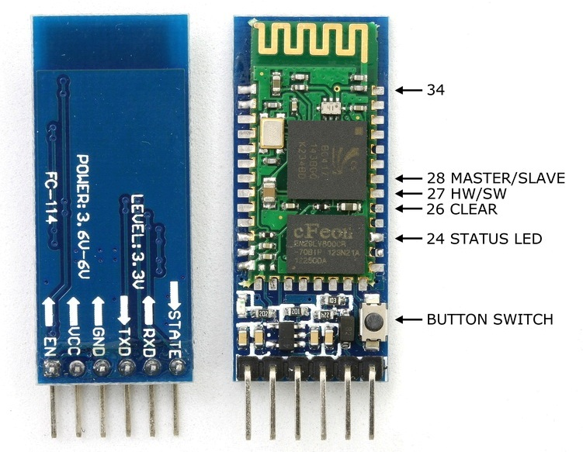

Fig 2.10: Bluetooth Module.

**2.5.2 Bluetooth Module Pins:**

There are 6 pins in Bluetooth module. They are given bellow:

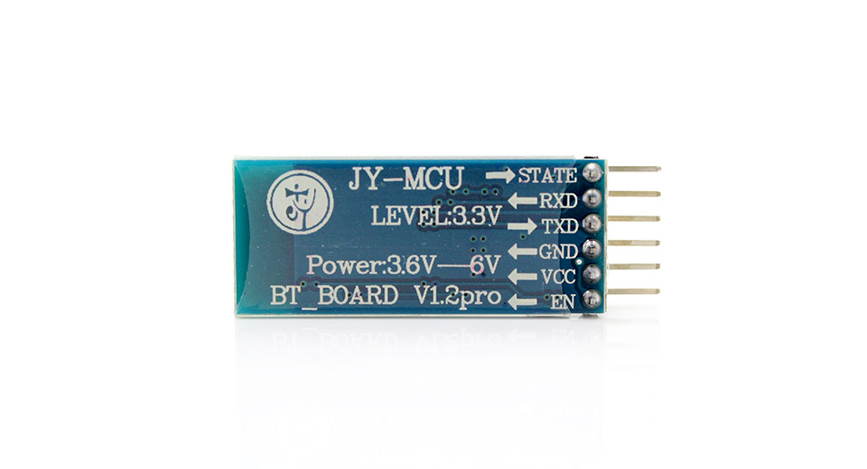

Fig 2.11: Pin diagram of Bluetooth Module.

**Enable (En):** When enable is pulled low the Bluetooth module is disabled and it will not be able to make any connection with other device as it is turned off. When enable is connected to 3.3V the module is turned on and it will make connection to other devices.

**VCC:** It is power supply pin of this module and the voltage range is 3.3V to 5V.

**GND:** It is the ground pin.

**TXD and RXD:** TXD and RXD pins are used for UART interface for communication.

**STATE:** It is used for indicating the state of the module. The signal goes low, when the module is not connected to or paired to other device. At this state the LED of the module flashes continuously which indicates that the module is not connected. When the module is connected to other device the state pin goes high. This time the LED flashes at a constant delay for example this delay can be 2s.

**Switch Button:** This helps the module to switch to AT COMMAND mode. To switch the AT COMMAND mode press the button for one second. By switching the mode user can change the parameters of this module but only if the module is not connected to other device. When it is connected to other device it remains busy to communicate with that device and fails to work on AT COMMAND mode.

**2.5.3 Features of Bluetooth module:**

* Typical ‐80dBm sensitivity.
* Up to +4dBm RF transmits power.
* 3.3 to 5 V I/O.
* PIO (Programmable Input/Output) control.
* UART interface with programmable baud rate.
* With integrated antenna.
* With edge connector.
* 2.4GHz radio transceiver and baseband.